## Lab 3

## Code Parse

Your name and student number must be at the top of every file.

You cannot use <string>or anything else except char ,ints and an array of chars.

Apart from cout, you **can only use functions that you have written**.

You may ask for some help but the code must be substantially yours.

You not use any form of plagiarism including generative AI.

All code must be consistently indented and variables given appropriate names.

Download lab3.h and lab3.cpp from blackboard .

Create a blank project. Add the cpp file and the h file to the project.

To Upload:

Code (lab3.h file and lab3.cpp)

# Parse C Code.

A.

void FindAllVariables(char variables[], char code[]) **15 Marks**

Write a function that takes 2 array of chars as parameters. The function fills the variable array to contain a comma separated list of the variable names that are declared in the code in the string. Only variables of type “int” and “char” need be included. Only one variable is declared per line.

Both variables array and code array have a max on 1000 chars.

Note strings are terminated by a 0.

For example

char code[1000] = “int main() \n{ \n int var1=10;\n int var2 =10;\n if(var1<10) \n {\n int var3=20;\n} \n}\ n”;

char newline = ‘\n’;

char variables[1000] ;”

FindAllVariables(variables ,code);

//variables now contains “var1,var2,var3”

B.

void FindVariablesInScope(char variables[], char code[], int lineNumber) **15 Marks**

Find variables in scope after a particular line number. The code won’t contain “for” loops. Only variables of type “int” and “char” need be included. Only one variable is declared per line. The only function declaration in the code is “int main()”.

Example:

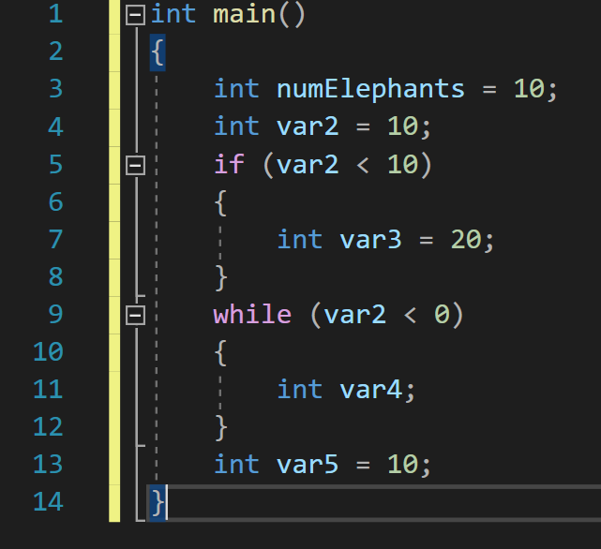

char code[1000] = “int main()\n{ \n int numElephants = 10;\n int var2 = 10; \n if (var2 < 10)\n{\nint var3 = 20;\n}\n while(var2 < 0)\n { \n if (var2 == 10) \n { \n int var4; \n } \n int num = 10; \n } \n int var5 = 10; \n }”;

char variables[1000] ;

FindVariablesInScope(variables,code,17); // the line with “int var5 = 10;”

//variables now contains “numElephants,var2,var5”

FindVariablesInScope(variables,code,13);

//variables now contains “numElephants,var2,var4”

**Testing**

Create tests that you did to show that the code is tested well. It is up to you to demonstrate that it works correctly.